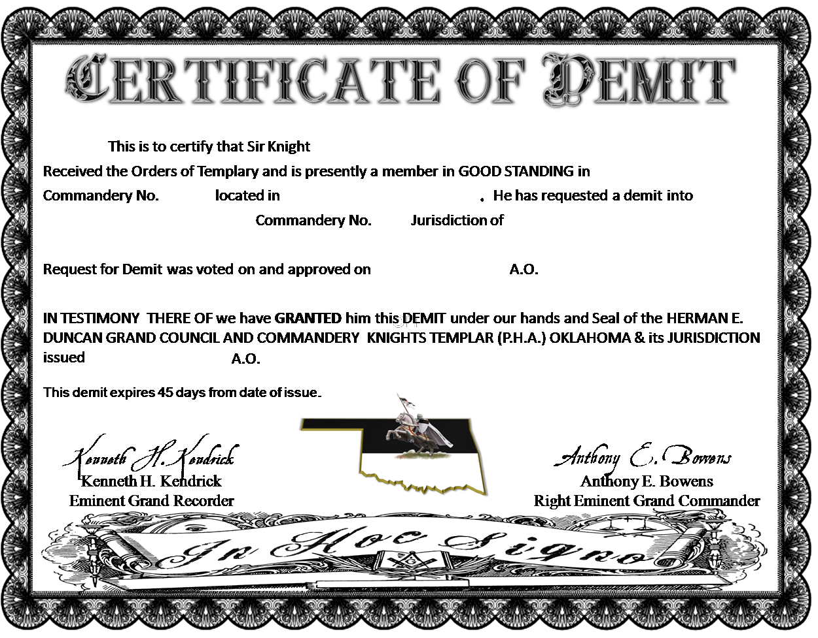

The Recorder of the Commandery with which the Sir Knight named in the attached Demit affiliates, is requested to complete this partition, detach and forward it to the address given below.
This is to certify that Sir Knight
to whose demit dated |  |  |  |  |  |  |  |  | A.O. |  |  | with this form detached, became a member of
 |  |  |  |  | Commandery No. |  |  |  |  | of
Jurisdiction of the |  |  |  |  |  |  |  |  |  | Grand Commandery, PHA
On this day |  |  |  |  |  |  | A.O.
 |  | Secretary |  |  |  |  |  |  |  |  |  |  | Commander
 |  |  |  |  |  |  | Seal

